WIRELESS COMMUNICATION PROJECT REPORT

**Interface GPS module with Node MCU**

**TABLE OF CONTENTS**

1. **Introduction to IOT 4**
2. **Introduction to Node MCU 5**
3. **Introduction to GPS module 7**
4. **Aim and interfacing 9**
5. **Source Code 10**
6. **Result 11**
7. **Bibliography 12**

**INTRODUCTION TO IOT**

**Internet of Things (IoT)** is the networking of physical objects that contain electronics embedded within their architecture in order to communicate and sense interactions amongst each other or with respect to the external environment. In the upcoming years, IoT-based technology will offer advanced levels of services and practically change the way people lead their daily lives. Advancements in medicine, power, gene therapies, agriculture, smart cities, and smart homes are just a very few of the categorical examples where IoT is strongly established.

Over 9 billion ‘Things’ (physical objects) are currently connected to the Internet, as of now. In the near future, this number is expected to rise to a whopping 20 billion.

There are four main components used in IoT:

1. **Low-power embedded systems –**  
   Less battery consumption, high performance are the inverse factors play a significant role during the design of electronic systems.
2. **Cloud computing –**  
   Data collected through IoT devices is massive and this data has to be stored on a reliable storage server. This is where cloud computing comes into play. The data is processed and learned, giving more room for us to discover where things like electrical faults/errors are within the system.
3. **Availability of big data –**  
   We know that IoT relies heavily on sensors, especially real-time. As these electronic devices spread throughout every field, their usage is going to trigger a massive flux of big data.
4. **Networking connection –**  
   In order to communicate, internet connectivity is a must where each physical object is represented by an IP address. However, there are only a limited number of addresses available according to the IP naming. Due to the growing number of devices, this naming system will not be feasible anymore.



**INTRODUCTION TO NODE MCU**

NodeMCU is an open source [LUA](https://www.lua.org/start.html) based firmware developed for ESP8266 wifi chip. By exploring functionality with ESP8266 chip, NodeMCU firmware comes with ESP8266 Development board/kit i.e. NodeMCU Development board.

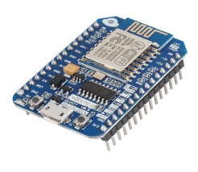

**NodeMCU Development Board/kit v0.9 (Version1)**

Since NodeMCU is open source platform, their hardware design is open for edit/modify/build.

NodeMCU Dev Kit/board consist of ESP8266 wifi enabled chip. The **ESP8266** is a low-cost [Wi-Fi](https://en.wikipedia.org/wiki/Wi-Fi) chip developed by Espressif Systems with TCP/IP protocol. For more information about ESP8266, you can refer [ESP8266 WiFi Module](http://www.electronicwings.com/sensors-modules/esp8266-wifi-module).

There is Version2 (V2) available for NodeMCU Dev Kit i.e. **NodeMCU Development Board v1.0 (Version2)**, which usually comes in black colored PCB.

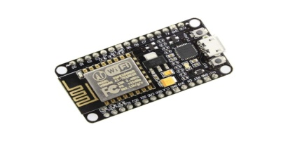

**NodeMCU Development Board/kit v1.0 (Version2)**

For more information about NodeMCU Boards available in market refer [NodeMCU Development Boards](http://www.electronicwings.com/nodemcu/nodemcu-development-kitboard)

NodeMCU Dev Kit has **Arduino like** Analog (i.e. A0) and Digital (D0-D8) pins on its board.

It supports serial communication protocols i.e. UART, SPI, I2C etc.

Using such serial protocols we can connect it with serial devices like I2C enabled LCD display, Magnetometer HMC5883, MPU-6050 Gyro meter + Accelerometer, RTC chips, GPS modules, touch screen displays, SD cards etc

**INTRODUCTION TO GPS MODULE**

GPS Receiver Module

Introduction

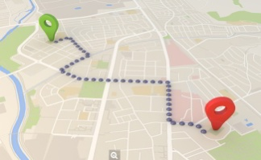

GPS receivers are generally used in smartphones, fleet management system, military etc. for tracking or finding location.

**G**lobal **P**ositioning **S**ystem (GPS) is a satellite-based system that uses satellites and ground stations to measure and compute its position on Earth.

GPS is also known as Navigation System with Time and Ranging (NAVSTAR) GPS.

GPS receiver needs to receive data from at least 4 satellites for accuracy purpose. GPS receiver does not transmit any information to the satellites.

This GPS receiver is used in many applications like smartphones, Cabs, Fleet management etc.

How GPS Works

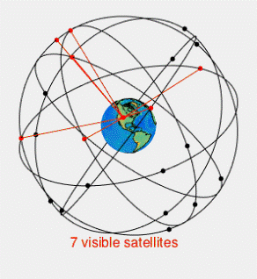

**GIF Source: Wikipedia**

GPS receiver uses a constellation of satellites and ground stations to calculate accurate location wherever it is located.

These GPS satellites transmit information signal over radio frequency (1.1 to 1.5 GHz) to the receiver. With the help of this received information, a ground station or GPS module can compute its position and time.

How GPS Receiver Calculates its Position and Time

GPS receiver receives information signals from GPS satellites and calculates its distance from satellites. This is done by measuring the time required for the signal to travel from satellite to the receiver.

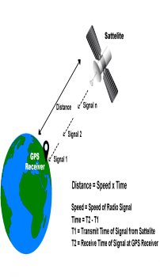

**GPS Distance Calculation**

**\textbf{Distance = Speed x Time}**

Where,

Speed = Speed of Radio signal which is approximately equal to the speed of light i.e.3*10^{8}

Time = Time required for a signal to travel from the satellite to the receiver.

By subtracting the sent time from the received time, we can determine the travel time.

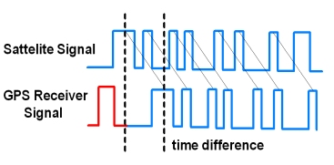

**GPS Signal Time Difference**

To determine distance, both the satellite and GPS receiver generate the same pseudocode signal at the same time.

The satellite transmits the pseudocode; which is received by the GPS receivers.These two signals are compared and the difference between the signals is the time.

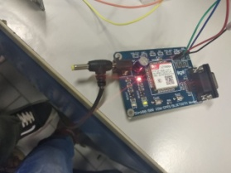

GPS MODULE

**INTRODUCTION TO BLYNK APP**

**Blynk Platform:**

**Blynk can control hardware remotely. It can display sensor**

**data,visualize. The three main components of Blynk are**

**Blynk server, Blynk libraries, Blynk app. Using Blynk app**

**we can create different widgets according to the**

**requirements. Blynk server is responsible for the**

**communication between hardware and the smartphone.**

**Features of Blynk platform:**

**1. Can connect cloud using WIFI, Bluetooth, USB,**

**GSM**

**2. Easy to use Widgets**

**3. Emails, twitter, notifications can be sent**

**AIM AND INTERFACING**

**AIM:** To interface GPS module with Node MCU to track the location using BLYNK App

**INTERFACING:**

### **Interfacing GPS with ESP12E NodeMCU:**

NodeMCU is ESP8266 based development board. It features ESP-12E as its processing core. It is a 32bit MCU. It has 14 GPIO pins, single channel 10 bit integrated ADC. It supports UART, I2C, SPI communication. It is 3.3V compatible, it cannot handle 5V. If you are new to NodeMCU then read our [Getting Started with NodeMCU ESP-12](https://circuitdigest.com/microcontroller-projects/getting-started-with-nodemcu-esp12).

The **connections between NodeMCU and GPS module** is as shown below.

|  |  |
| --- | --- |
| **NodeMCU** | **GPS module** |
| 3V3 | Vcc |
| GND | GND |
| D1 (GPIO5) | RX |
| D2 (GPIO4) | TX |

Below is **the circuit Diagram of connecting GPS with NodeMCU**:

[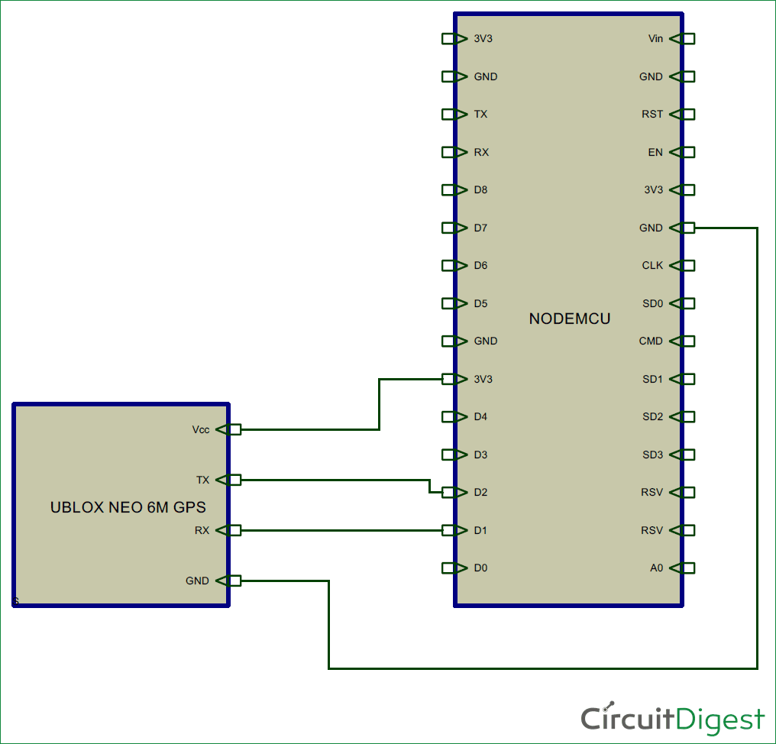](https://circuitdigest.com/fullimage?i=circuitdiagram_mic/Circuit-diagram-for-GPS-Interfacing-with-NodeMCU_0.png)

GPS module takes some time to capture location details once it is powered on. NodeMCU starts webserver and waits for a client to get connected to the webserver. Once client is connected to the webserver, NodeMCU sends location details to connected client. The location details are displayed in a simple webpage designed using HTML.

**Steps:**

1. Connect the circuit as shown in the schematic.

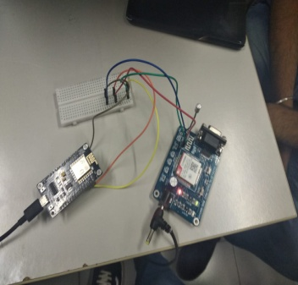

1. Upload the code after changing Wi-Fi credentials.
2. Open serial monitor in Arduino IDE and note down IP address of the webserver. 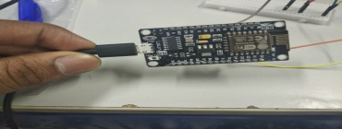
3. Open Blynk app and get the gps location.
4. It will display Location details, date, time and Google maps link.

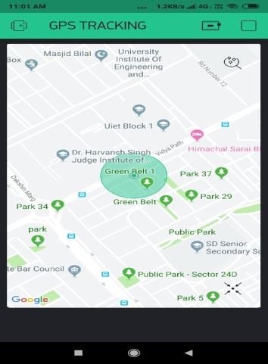

**SOURCE CODE**

|  |  |  |  |  |
| --- | --- | --- | --- | --- |
|  | #define BLYNK_PRINT Serial #include <SPI.h> #include <ESP8266WiFi.h> #include <BlynkSimpleEsp8266.h> char auth[] = "d5392cf3628a42769db2291962bcebf1"; // Your WiFi credentials. // Set password to "" for open networks. char ssid[] = "Swatiii"; char pass[] = "1234567890"; WidgetMap myMap(V1); void setup() {   // Debug console   Serial.begin(9600);    Blynk.begin(auth, ssid, pass);      myMap.clear();    int index = 1;   float lat = 51.5074;   float lon = 0.1278;   myMap.location(index, lat, lon, "value"); }  void loop() {   Blynk.run(); }   |  |  | | --- | --- | |  |  | |  |

**RESULT:**

**1.User will get all the location details in the installed blynk app**

**2.After extending ,user can also get the details of direction ,latitude and longitude**

**FUTURE SCOPE:**

**GPS (Global Positioning System) is a piece of technology that allows billions of users every day to locate themselves, their friends or their things and navigate around our world in a way we could have only dreamt of a few years ago. This innovation has progressed in a few decades from a military project to an indispensable daily resource with all manner of benefits we’ve all got used to, but also limitations we’ve learned to live with. On the plus side, your phone or your car or any other device can instantly locate where you are in the world and share that with a Geographic Information System (GIS) such as Google Maps or your car onboard system which then gives you the best route, and turn by turn directions to your destination including taking into account traffic and disruptions. On the downside, GPS is notoriously hungry for the battery it does not work indoors, and it requires an expensive chip to calculate your position as well as a data link to send the information to the Internet. There have been alternative solutions for communication standards such as Bluetooth or Wi-Fi which have proven to be quite challenging due to short-range limits of these networks and devices as well as relatively short battery life. So the ideal solution to track anything should:**

**1) work indoors and outdoors**

**2) offer a long battery life**

**3) have a good radio range**

**4) be inexpensive to set up and run**

**5) not require a router for every few meters.**

**BIBLIOGRAPHY**

**-Google Inc.**

**-Design and Innovation Group(DIG),UIET,PU**

**-http://electrosome.com/interfacing-GPS-module-Node MCU/**

**-www.electronicsforum.co.in**

**-www.circuitdigest.com**